Session 18

- Write an SQL query to display the total number of songs uploaded by each artist from a table 'songs' (columns: song_id, artist_name, title) and show only those artists who have uploaded more than 3 songs.
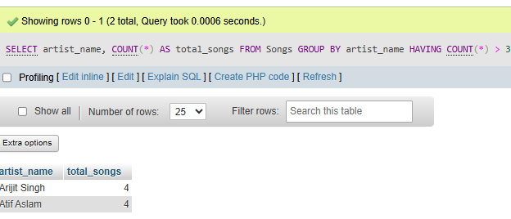

- Given two tables, 'orders' (order_id, user_id, amount) and 'users' (user_id, username), write a SQL JOIN query to display each username along with their total order amount.

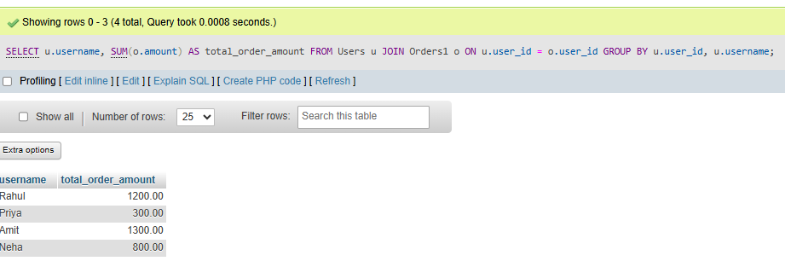

3. Write a SQL subquery to find the names of all restaurants from a 'restaurants' table (id, name, rating) whose rating is higher than the average rating of all restaurants.

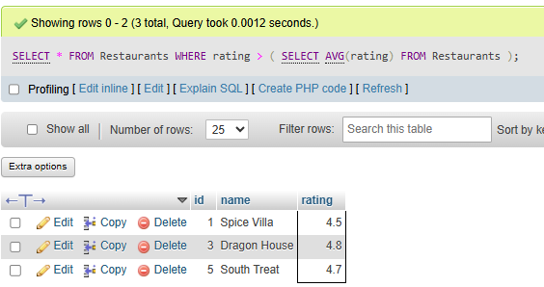

4.Using a 'transactions' table (id, user_id, amount, transaction_date), write a SQL query with a window function to display each user's transaction amount and their running total (cumulative sum) ordered by transaction_date.
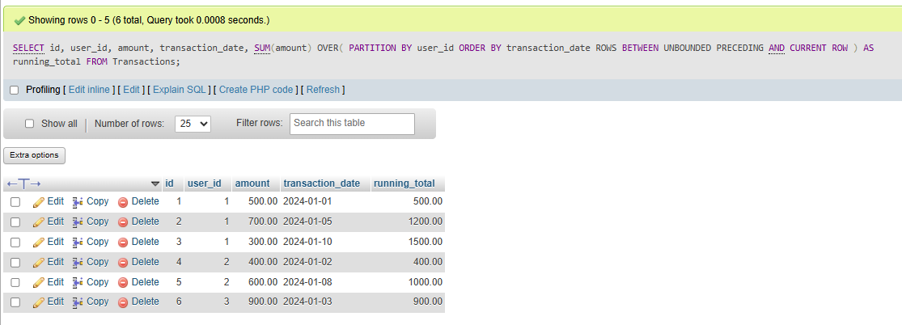

5. List two optimizations you would apply to speed up a query that filters Flipkart products by category and price, and briefly explain how each helps.<br><br><em><strong>Hint:</strong> Think about indexes and query structure.</em>

Doubt

